Command for Log File

SET NOCOUNT ON;

DECLARE @cmd VARCHAR(8000), @dbName VARCHAR(200)='WDMRP7', @path VARCHAR(200)='D:\TextDB\', @tableName VARCHAR(200)='tblTest',

@data_start_dt DateTime = '2011-10-01 10:15:00.000', @data_end_dt DateTime = '2018-12-30 00:00:00.000',

@pathAndFileName NVARCHAR(MAX);

SET @pathAndFileName = @dbName + '.dbo.'+ @tableName

SET @cmd=

'BCP '+

'"select ''Total Count : '' + CONVERT(varchar(10), COUNT(1)) from ' + @pathAndFileName + ' where data_start_dt >= ''' + Convert(varchar ,@data_start_dt ) + ''' and data_end_dt <=''' + Convert(varchar ,@data_end_dt ) + '''" '

+ 'QUERYOUT ' + @path + @dbName+ '.'+ @tableName +'.' +convert(varchar(500),GetDate(),112) + '.log '

+ '-c -t, -T -S ' + @@SERVERNAME

print @cmd

EXEC master..xp_cmdshell @cmd;

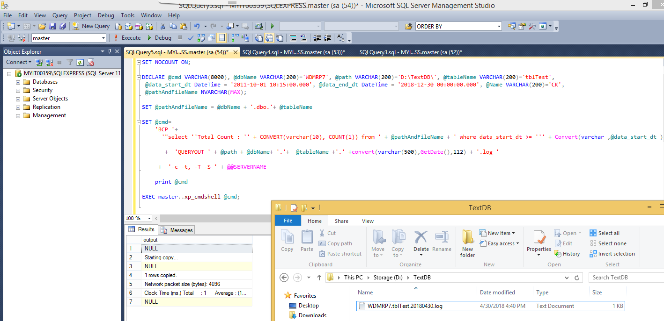

**Log File Output**

Command for Json File

declare @bcp_cmd varchar(2000), @bcp_passwd VarChar(100), @bcp_user VarChar(100), @SERVERNAME VarChar(100), @output_dir VarChar(100), @filename VarChar(100), @LinkedServerName VarChar(100),@sql varchar(2000),@dbName VARCHAR(200)='WDMRP7',@viewName VARCHAR(200)='VQIS_ET2';

set @SERVERNAME = 'MYIT00359\SQLEXPRESS';set @bcp_user ='sa';set @bcp_passwd ='sa';

set @output_dir = 'D:\TextDB\';

set @filename = @dbName+ '.'+ @viewName +'.' +convert(varchar(500),GetDate(),112) + '.json';

set @LinkedServerName = '[WDMR2G.WORLD]';

set @sql = 'select * from openquery('+ @LinkedServerName +',' + '''select repadmin.GetJson(''''VQIS_ET2'''',''''QIS_CONTROLLER'''') from dual''' + ')'

print @sql

SET @bcp_cmd = 'bcp.exe "' + @sql

SET @bcp_cmd= @bcp_cmd + '" QUERYOUT "' + @output_dir + @filename +'" '

SET @bcp_cmd = @bcp_cmd + ' -k -S ' + @SERVERNAME

SET @bcp_cmd = @bcp_cmd + ' -U "'+@bcp_user+'" -P "'+@bcp_passwd +'"'+' -c'

print @bcp_cmd

EXEC master..xp_cmdshell @bcp_cmd;

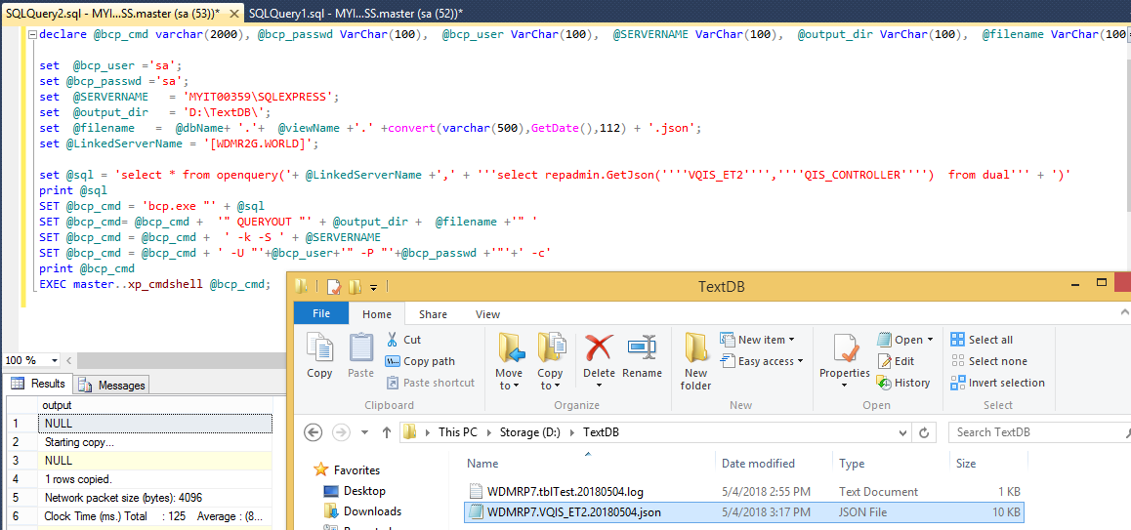

**Json** **Output**

Command for CSV File

declare @bcp_cmd varchar(2000), @bcp_passwd VarChar(100), @bcp_user VarChar(100), @tablename VarChar(100),

@packet_size int, @SERVERNAME VarChar(100), @output_dir VarChar(100), @filename VarChar(100),@dbName VARCHAR(200)='WDMRP6',@viewName VARCHAR(200)='VQIS_ET2';

set @bcp_user ='sa';set @bcp_passwd ='sa'; set @tablename = '[WDMRP6.WORLD]..[QIS_CONTROLLER].[VQIS_ET2]';

set @SERVERNAME = 'MYIT00359\SQLEXPRESS';set @output_dir = 'D:\TextDB\';set @packet_size=1024;

set @filename = @dbName+ '.'+ @viewName +'.' +convert(varchar(500),GetDate(),112) + '.csv';

SET @bcp_cmd = 'bcp.exe "SELECT top 10 * FROM ' + @tablename + ';'

SET @bcp_cmd= @bcp_cmd + '" QUERYOUT "' + @output_dir + @filename +'" '

SET @bcp_cmd = @bcp_cmd + ' -k -S ' + @SERVERNAME

SET @bcp_cmd = @bcp_cmd + ' -U "'+@bcp_user+'" -P "'+@bcp_passwd +'" -a '+cast(@packet_size as varchar(10)) +' -c -t "^" -r "=|\n" '

print @bcp_cmd

EXEC master..xp_cmdshell @bcp_cmd

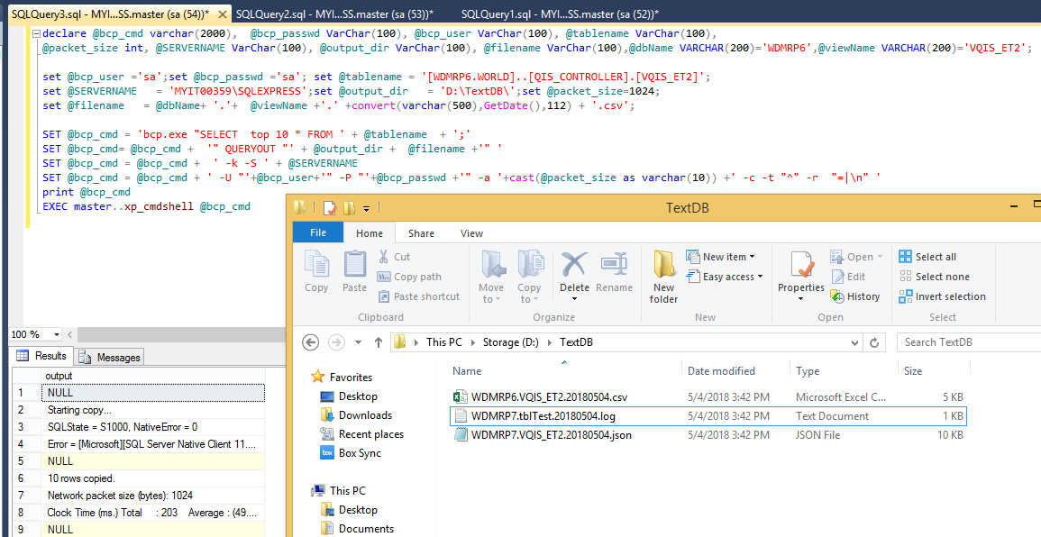

**CSV** **Output**

Command for ZiP File

DECLARE @results TABLE(results varchar(255))

declare @command varchar(2000),@dbName VARCHAR(200)='WDMRP6',@viewName VARCHAR(200)='VQIS_ET2', @filename VarChar(100),@path varchar(200)='D:\TextDB\'

set @filename = @dbName+ '.'+ @viewName +'.' +convert(varchar(500),GetDate(),112) ;

SET @command =

'"C:\Program Files\7-Zip\' --path to 7za command line utility note the dbl quotes for long file names!

+ '7zG.exe"' --the exe: i'm using in the command line utility.

+ ' a ' --the Add command: add to zip file:

+ @path --path for zip

+ @filename + '.zip' --zip file name, note the dbl quotes for long file names!

+ ' ' --whitespace between zip file and file to add

+ @path --path for the files to add

+ @filename + '.csv' --the file

+ ' -y' --suppress any dialogs by answering yes to any and all prompts

print @command

insert into @results

exec xp_cmdshell @command

DECLARE @DeleteFilename VARCHAR(50)='del '+@path + @filename + '.csv'; EXEC xp_cmdshell @DeleteFilename;

select * from @results

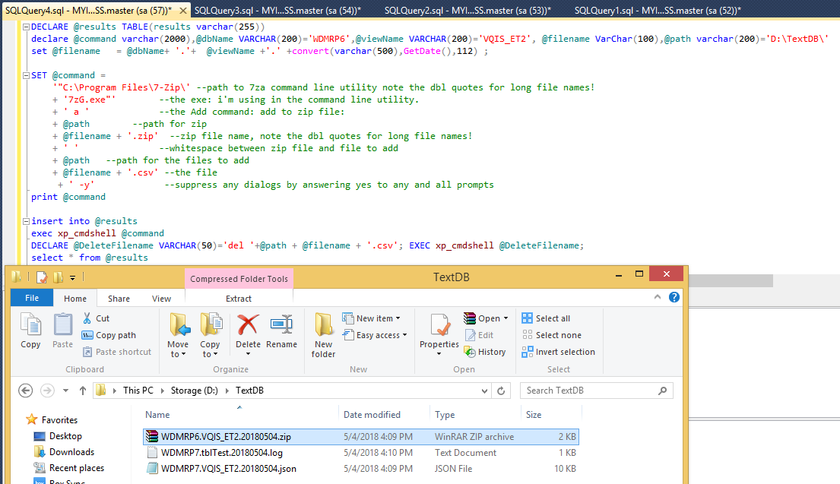

**Zip** **File Output**

<[NobleKing.Constantin@wdc.com](mailto:NobleKing.Constantin@wdc.com)>  
**Subject:** RE: Research and testing on mysql export csv, json, log

This is the sample to pass in view name and owner. Please try it out in WDMR2G using sql express to call this function and write as file content and save as “XXXXXX.json”

declare

strclob clob;

begin

select repadmin.GetJson('VQIS_ET2','QIS_CONTROLLER') into strclob from dual;

end;

**From:** Cheng Kean Tan   
**Sent:** Wednesday, April 25, 2018 10:54 AM  
**To:** MOHAMMAD NAZMUL HUDA RUBOL CHOWDHURY <[MOHAMMAD.NAZMUL.HUDA.RUBOL.CHOWDHURY@wdc.com](mailto:MOHAMMAD.NAZMUL.HUDA.RUBOL.CHOWDHURY@wdc.com)>  
**Cc:** MUHAMMAD ASIM NAEEM <[MUHAMMADASIM.NAEEM@wdc.com](mailto:MUHAMMADASIM.NAEEM@wdc.com)>; Noble King Constantin <[NobleKing.Constantin@wdc.com](mailto:NobleKing.Constantin@wdc.com)>  
**Subject:** RE: Research and testing on mysql export csv, json, log

Hi Nazmul,

Can you try this query In sql express and let me know?

select * from openquery([WDMR2G],'

select ''{"fields":['' ||

(

select stragg2(''{''

       ||''"COLUMN_NAME":"''||column_name||''"''

       ||'',"DATA_TYPE":"''||data_type||''"''

       ||'',"MAX_LENGTH":''||data_length||''''

       ||'',"PRECISION":''|| case when data_precision is not null then '''' || data_precision || '''' else ''null'' end||''''

       ||'',"SCALE":''||case when data_scale is not null then '''' || data_scale  || '''' else ''null'' end||''''

       ||'',"IS_NULLABLE":"''||NULLABLE||''"''

       ||''}'' )

from

(

select

    column_name,

    data_type,

    data_length,

    data_precision,

    data_scale,

    nullable

from all_tab_columns

where table_name=''VQIS_ET2''

and owner=''QIS_CONTROLLER''

order by column_id

)

)

|| '']}'' from dual

')

Thanks.

**From:** Cheng Kean Tan   
**Sent:** Monday, April 16, 2018 10:38 AM  
**To:** MOHAMMAD NAZMUL HUDA RUBOL CHOWDHURY <[MOHAMMAD.NAZMUL.HUDA.RUBOL.CHOWDHURY@wdc.com](mailto:MOHAMMAD.NAZMUL.HUDA.RUBOL.CHOWDHURY@wdc.com)>  
**Cc:** MUHAMMAD ASIM NAEEM <[MUHAMMADASIM.NAEEM@wdc.com](mailto:MUHAMMADASIM.NAEEM@wdc.com)>; Noble King Constantin <[NobleKing.Constantin@wdc.com](mailto:NobleKing.Constantin@wdc.com)>  
**Subject:** RE: Research and testing on mysql export csv, json, log

Hi Nazmul,

1)Please configure sql server express to execute xp_cmdshell like below:

2)Create a stored procedure to export csv files and log files  to d:\.... (parameters to pass in is starttime and endtime)

SET @bcp_cmd = 'bcp.exe "SELECT * FROM ' + @dbname + '.dbo.'+ @tablename

SET @bcp_cmd = @bcp_cmd + ' WITH (NOLOCK) WHERE DB_UPDATE_DATE_TIME >= '

SET @bcp_cmd = @bcp_cmd + ''''

SET @bcp_cmd = @bcp_cmd +@data_start_dt+ ''''+' AND DB_UPDATE_DATE_TIME < '+''''

SET @bcp_cmd = @bcp_cmd +@data_end_dt+ '''' + ' ;'

SET @bcp_cmd = @bcp_cmd + '" queryout "' + @output_dir + @filename+'"'

SET @bcp_cmd = @bcp_cmd +' -k -S '+@server_name

SET @bcp_cmd = @bcp_cmd + '-U "'+@bcp_user+'" -P "'+@bcp_passwd+'" -a '+cast(@packet_size as varchar(10)) +' -c -t "^" -r "\n" > '

SET @bcp_cmd = @bcp_cmd +@output_dir+'log\'+@table_name+'_'+@copy_dt2 + replace(CONVERT(varchar(5),@param_bcp_date,114),':','') + '.log'

--print @bcp_cmd

SET @bcp_cmd2 = @bcp_cmd

print @bcp_cmd2

exec master..xp_cmdshell @bcp_cmd2

Let me know if any issue.

Take initiative to ask question.

Thanks.

**From:** Cheng Kean Tan   
**Sent:** Tuesday, April 10, 2018 10:30 AM  
**To:** MOHAMMAD NAZMUL HUDA RUBOL CHOWDHURY <[MOHAMMAD.NAZMUL.HUDA.RUBOL.CHOWDHURY@wdc.com](mailto:MOHAMMAD.NAZMUL.HUDA.RUBOL.CHOWDHURY@wdc.com)>  
**Cc:** MUHAMMAD ASIM NAEEM <[MUHAMMADASIM.NAEEM@wdc.com](mailto:MUHAMMADASIM.NAEEM@wdc.com)>; Noble King Constantin <[NobleKing.Constantin@wdc.com](mailto:NobleKing.Constantin@wdc.com)>  
**Subject:** RE: Research and testing on mysql export csv, json, log

Hi Nazmul,

Please follow the instruction below.

You need to use mysql to create stored procedure script in order to do export.

You might need a connector to connect from mysql to oracle database. Please try it out and let me know.

Please take initiative to ask questions if you have.

Thanks.

**From:** Cheng Kean Tan   
**Sent:** Thursday, April 5, 2018 11:37 AM  
**To:** MOHAMMAD NAZMUL HUDA RUBOL CHOWDHURY <[MOHAMMAD.NAZMUL.HUDA.RUBOL.CHOWDHURY@wdc.com](mailto:MOHAMMAD.NAZMUL.HUDA.RUBOL.CHOWDHURY@wdc.com)>  
**Cc:** MUHAMMAD ASIM NAEEM <[MUHAMMADASIM.NAEEM@wdc.com](mailto:MUHAMMADASIM.NAEEM@wdc.com)>; Noble King Constantin <[NobleKing.Constantin@wdc.com](mailto:NobleKing.Constantin@wdc.com)>  
**Subject:** Research and testing on mysql export csv, json, log

Hi Nazmul,

Please do a research and testing on mysql for the requirement below:

Using MYSQL and create procedure and export VQIS_ET2 view in WDMR2G using repuser between timestamp2 “2018-04-05 00:00:00” amd “2018-04-05 00:09:59”:

1)Export csv file from oracle database REPUSER@WDMR2G with delimeter “^” and next line delimeter “=|” \n. Filename same as .42 server.

2)Zip it as gz.

3)Export json format same as in .42 server based on query below:

select '{"fields":[' ||

(

select stragg2('{'

       ||'"COLUMN_NAME":"'||column_name||'"'

       ||',"DATA_TYPE":"'||data_type||'"'

       ||',"MAX_LENGTH":'||data_length||''

       ||',"PRECISION":'|| case when data_precision is not null then '' || data_precision || '' else 'null' end||''

       ||',"SCALE":'||case when data_scale is not null then '' || data_scale  || '' else 'null' end||''

       ||',"IS_NULLABLE":"'||NULLABLE||'"'

       ||'}' )

from

(

select

    column_name,

    data_type,

    data_length,

    data_precision,

    data_scale,

    nullable

from all_tab_columns

where table_name='VQIS_ET2'

and owner='QIS_CONTROLLER'

order by column_id

)

)

|| ']}' from dual

4)Export log file same as .42 server. This is count of that period of time.

MYSQL (use mysql workbench to connect)

10.165.136.42

Port 3306

Username: admin

password: admin